INTRODUCTION

*overview*

*Description of the project*

Project Description:

. Fresh Bites Catering, a catering service, utilizes Zoho Books to manage their sales, track inventory, and handle invoicing. They can generate professional invoices for clients and track expenses related to ingredients and supplies. Zoho Books helps them maintain accurate financial records and streamline their catering operations.

PURPOSE

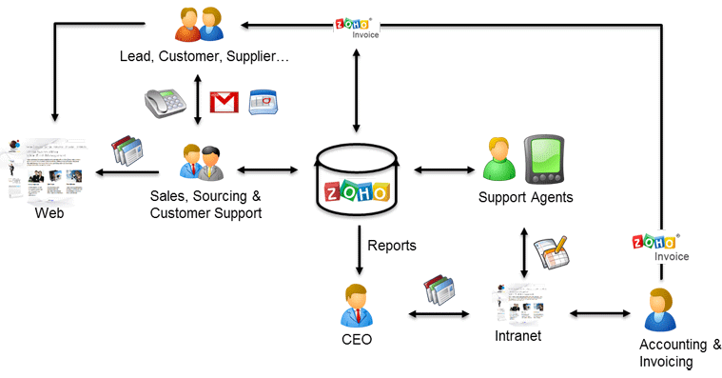

Empathy Map.

*y map*

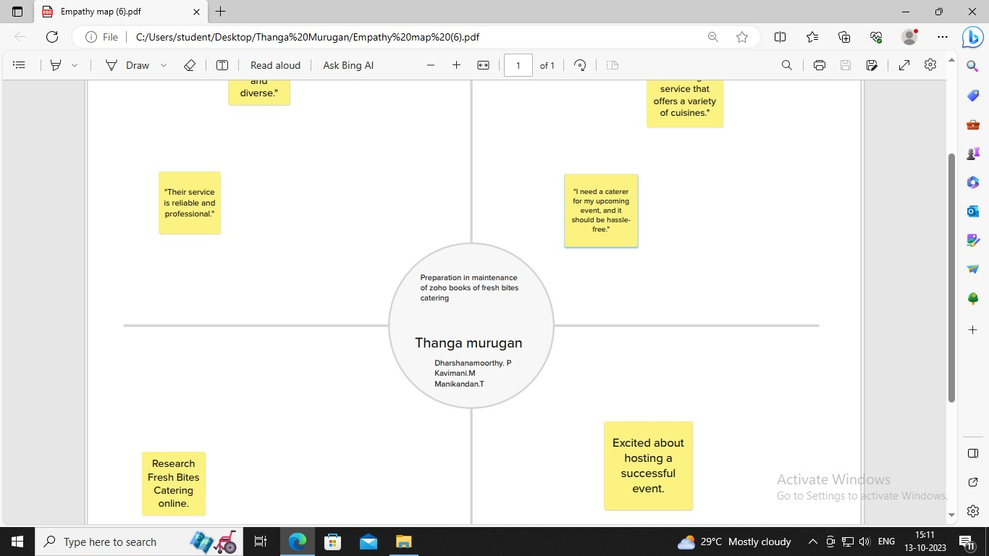

*Ideation & Brainstorming map*

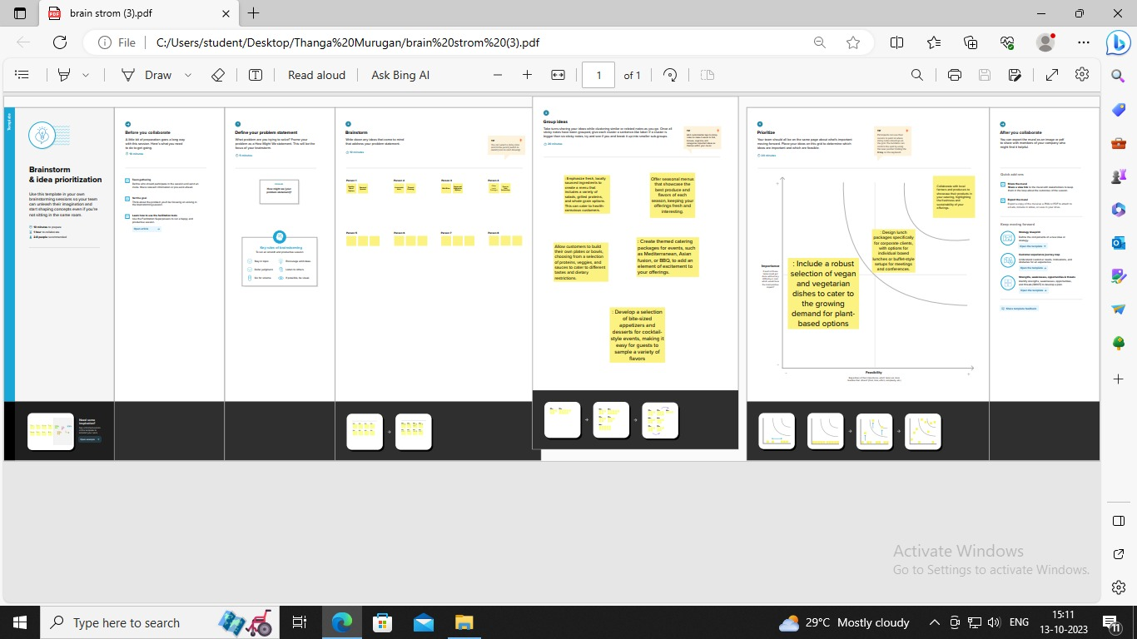

Result Profit&loss

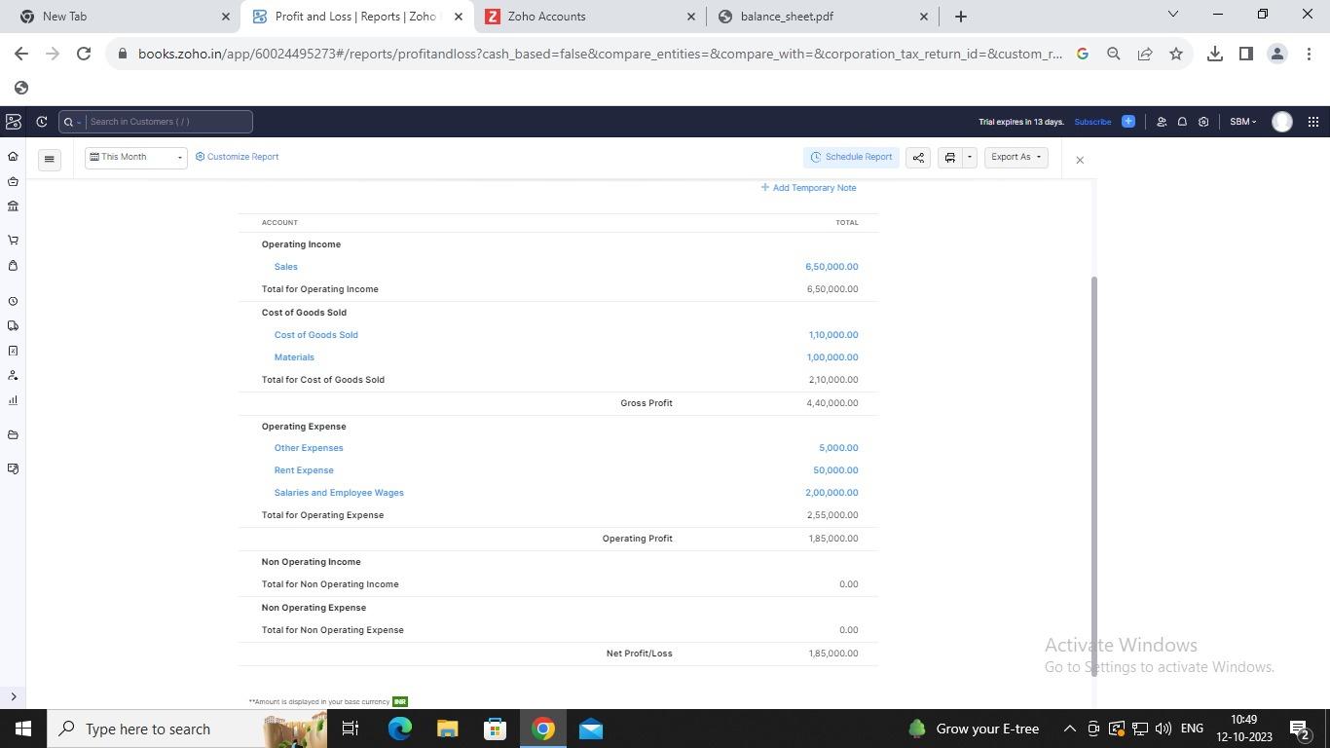

Balance sheet:

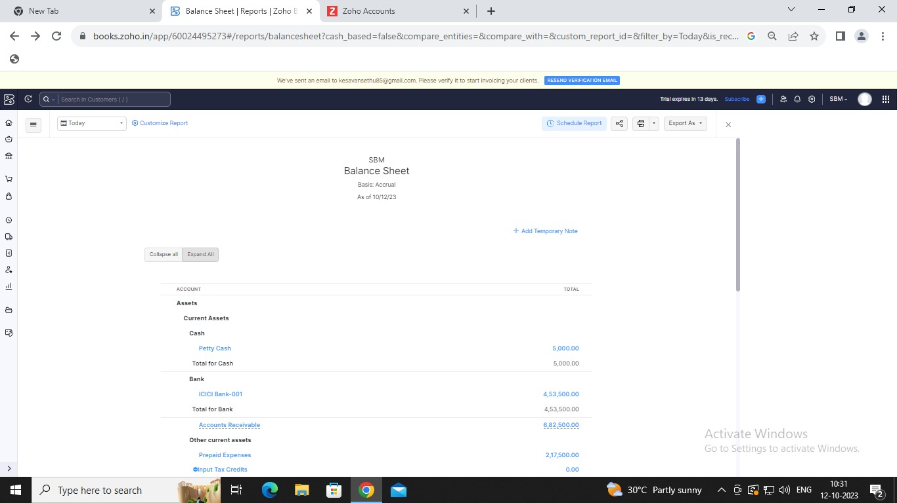

Purchase order:

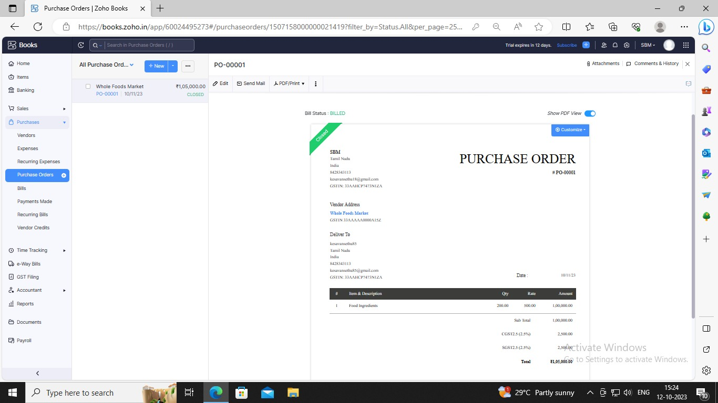

ADVANDAGES OF FRESH BITE CARETRING;

Fresh Bite Catering cater for schools, colleges and universities. We serve a wide selection

of food and beverages, whilst keeping in mind the nutritional needs of students by

offering a range of healthy meal plans. But we don't just serve any food –

we als prioritize the nutritional needs of students

disadvange of fresh bite catering;

Advantages of using a local caterer include: Fresh and locally-sourced ingredients:

Local caterers often use fresh an. Continue reading.

*APPLICATIONS:*

Food and beverages.

Conclusion:

Inadequate food is prevalent globally in all countries, and no country has a perfect foods system.

FUTURE SCOPE:

With the fast-paced services, there is a huge scope for a career in food and beverage

services in the upcoming future. Not only the food and beverage industry is an

important facet of all the hospitality organizations such

as airlines, railways, corporate canteens, and other allied industries.

APPENDIX:

<https://github.com/murugan23092003/Fresh-Bites-CateringNM2023TMID23134>

|  |  |
| --- | --- |
| <!DOCTYPE html> | |
|  | | <html lang="en" data-color-mode="auto" data-light-theme="light" data-dark-theme="dark" data-a11y-animated-images="system" data-a11y-link-underlines="false"> | | |
|  | |  | | |
|  | | <style> | | |
|  | | /* for each iteration, uncomment the CSS variable */ | | |
|  | |  | | |
|  | | /* light themes */ | | |
|  | | [data-color-mode="light"][data-light-theme*="light"], | | |
|  | | [data-color-mode="auto"][data-light-theme*="light"] { | | |
|  | | /* iteration 1 */ | | |
|  | | --border-color-iteration-1: #C8CCD0; | | |
|  | | /* iteration 2 */ | | |
|  | | --border-color-iteration-2: #BABFC5; | | |
|  | | /* iteration 3 */ | | |
|  | | --border-color-iteration-3: #A6ADB4; | | |
|  | | /* iteration final */ | | |
|  | | --border-color-iteration-4: #868F99; | | |
|  | |  | | |
|  | | /* the first value is the final step, which falls back to previous iterations */ | | |
|  | | --control-borderColor-rest: var(--border-color-iteration-4, var(--border-color-iteration-3, var(--border-color-iteration-2, var(--border-color-iteration-1)))) !important; | | |
|  | | } | | |
|  | |  | | |
|  | | /* dark themes */ | | |
|  | | [data-color-mode="dark"][data-dark-theme*="dark"], | | |
|  | | [data-color-mode="auto"][data-light-theme*="dark"] { | | |
|  | | /* iteration 1 */ | | |
|  | | --border-color-iteration-1: #363940; | | |
|  | | /* iteration 2 */ | | |
|  | | --border-color-iteration-2: #3F434B; | | |
|  | | /* iteration 3 */ | | |
|  | | --border-color-iteration-3: #4B5159; | | |
|  | | /* iteration final */ | | |
|  | | --border-color-iteration-4: #666E79; | | |
|  | |  | | |
|  | | /* the first value is the final step, which falls back to previous iterations */ | | |
|  | | --control-borderColor-rest: var(--border-color-iteration-4, var(--border-color-iteration-3, var(--border-color-iteration-2, var(--border-color-iteration-1)))) !important; | | |
|  | | } | | |
|  | |  | | |
|  | | [data-color-mode="dark"][data-dark-theme="dark_dimmed"], | | |
|  | | [data-color-mode="dark"][data-dark-theme="light_high_contrast"], | | |
|  | | [data-color-mode="dark"][data-dark-theme="dark_high_contrast"], | | |
|  | | [data-color-mode="light"][data-light-theme="dark_dimmed"], | | |
|  | | [data-color-mode="light"][data-light-theme="light_high_contrast"], | | |
|  | | [data-color-mode="light"][data-light-theme="dark_high_contrast"] { | | |
|  | | /* skip these themes, use the fallback */ | | |
|  | | --control-borderColor-rest: initial !important; | | |
|  | | } | | |
|  | |  | | |
|  | | @media (prefers-color-scheme: dark) { | | |
|  | | /* dark colors in dark mode */ | | |
|  | | [data-color-mode="auto"][data-dark-theme*="dark"] { | | |
|  | | /* iteration 1 */ | | |
|  | | --border-color-iteration-1: #363940; | | |
|  | | /* iteration 2 */ | | |
|  | | --border-color-iteration-2: #3F434B; | | |
|  | | /* iteration 3 */ | | |
|  | | --border-color-iteration-3: #4B5159; | | |
|  | | /* iteration final */ | | |
|  | | --border-color-iteration-4: #666E79; | | |
|  | |  | | |
|  | | /* the first value is the final step, which falls back to previous iterations */ | | |
|  | | --control-borderColor-rest: var(--border-color-iteration-4, var(--border-color-iteration-3, var(--border-color-iteration-2, var(--border-color-iteration-1)))) !important; | | |
|  | | } | | |
|  | |  | | |
|  | | /* light colors in dark mode */ | | |
|  | | [data-color-mode="auto"][data-dark-theme*="light"] { | | |
|  | | /* iteration 1 */ | | |
|  | | --border-color-iteration-1: #C8CCD0; | | |
|  | | /* iteration 2 */ | | |
|  | | --border-color-iteration-2: #BABFC5; | | |
|  | | /* iteration 3 */ | | |
|  | | --border-color-iteration-3: #A6ADB4; | | |
|  | | /* iteration final */ | | |
|  | | --border-color-iteration-4: #868F99; | | |
|  | |  | | |
|  | | /* the first value is the final step, which falls back to previous iterations */ | | |
|  | | --control-borderColor-rest: var(--border-color-iteration-4, var(--border-color-iteration-3, var(--border-color-iteration-2, var(--border-color-iteration-1)))) !important; | | |
|  | | } | | |
|  | |  | | |
|  | | [data-color-mode="auto"][data-dark-theme="dark_dimmed"], | | |
|  | | [data-color-mode="auto"][data-dark-theme="light_high_contrast"], | | |
|  | | [data-color-mode="auto"][data-dark-theme="dark_high_contrast"] { | | |
|  | | /* skip these themes, use the fallback */ | | |
|  | | --control-borderColor-rest: initial !important; | | |
|  | | } | | |
|  | | } | | |
|  | |  | | |
|  | | @media (prefers-color-scheme: light) { | | |
|  | | /* dark colors in light mode */ | | |
|  | | [data-color-mode="auto"][data-light-theme*="dark"] { | | |
|  | | /* iteration 1 */ | | |
|  | | --border-color-iteration-1: #363940; | | |
|  | | /* iteration 2 */ | | |
|  | | --border-color-iteration-2: #3F434B; | | |
|  | | /* iteration 3 */ | | |
|  | | --border-color-iteration-3: #4B5159; | | |
|  | | /* iteration final */ | | |
|  | | --border-color-iteration-4: #666E79; | | |
|  | |  | | |
|  | | /* the first value is the final step, which falls back to previous iterations */ | | |
|  | | --control-borderColor-rest: var(--border-color-iteration-4, var(--border-color-iteration-3, var(--border-color-iteration-2, var(--border-color-iteration-1)))) !important; | | |
|  | | } | | |
|  | |
|  | |  |
|  | |  |
|  | |  |
|  | |  |
|  | |  |
|  | |  |
|  | |  |
|  | |  |
|  | |  |
|  | |  |
|  | |  |
|  | |  |
|  | |  |
|  | |  |
|  | |  |
|  | |  |
|  | |  |
|  | |  |
|  | |  |
|  | |  |
|  | |  |
|  | |  |
|  | |  |
|  | |  |
|  | |  |
|  | |  |
|  | |  |
|  | |  |
|  | |  |
|  | |  |
|  | |  |
|  | |  |
|  | |  |
|  | |  |
|  | |  |
|  | |  |
|  | |  |
|  | |  |
|  | |  |
|  | |  |
|  | |  |
|  | |  |
|  | |  |
|  | |  |
|  | |  |
|  | |  |
|  | |  |
|  | |  |
|  | |  |
|  | |  |
|  | |  |
|  | |  |
|  | |  |
|  | |  |
|  | |  |
|  | |  |
|  | |  |
|  | |  |
|  | |  |
|  | |  |
|  | |  |
|  | |  |
|  | |  |
|  | |  |
|  | |  |
|  | |  |
|  | |  |
|  | |  |
|  | |  |
|  | |  |
|  | |  |
|  | |  |
|  | |  |
|  | |  |
|  | |  |
|  | |  |
|  | |  |
|  | |  |
|  | |  |
|  | |  |
|  | |  |
|  | |  |
|  | |  |
|  | |  |
|  | |  |
|  | |  |
|  | |  |
|  | |  |
|  | |  |
|  | |  |
|  | |  |
|  | |  |
|  | |  |
|  | |  |
|  | |  |
|  | |  |
|  | |  |
|  | |  |
|  | |  |
|  | |  |
|  | |  |
|  | |  |
|  | |  |
|  | |  |
|  | |  |
|  | |  |
|  | |  |
|  | |  |
|  | |  |
|  | |  |
|  | |  |
|  | |  |
|  | |  |
|  | |  |
|  | |  |
|  | |  |
|  | |  |
|  | |  |
|  | |  |
|  | |  |
|  | |  |
|  | |  |
|  | |  |